Oven vs. Board Profiling For the Production Environment

By Paul Austen, Senior Project Engineer, ECD

Key Words: Ovens, Oven Profiling, Thermal Profiling, Reflow Soldering, High-Volume Production

(Approximately 1,143 words without bio or references)

Profiling Alternatives
Thermal Profiling is a recognized necessity. As mid-to-high volume production continues to dominate in many areas, it is beneficial to understand the available choices in profiling, and which ones will work best under what circumstances. One of the main distinctions to be made is between board profiling and oven profiling. Having said that, it must be clear as to exactly when it is possible to effectively replace board profiling with oven profiling, the benefits of doing so, and the parameters that are required for successful implementation.

The obvious distinction is simple. In board profiling you are placing multiple thermocouples on a populated board to ensure the target thermal profile specified by the OEM or solder paste manufacturer is met during reflow. That process is then repeated with each subsequent run to provide both verification and documentation that it is in spec, meeting that same target profile. There is, however, wear and tear on any populated board that is repeatedly profiled, resulting in occasional product loss. In addition, there is a certain amount of time required for whatever method (soldering or tape) is used to attach thermocouples, and there is always downtime involved as you switch from product to product (changeover), which often require different target profiles or oven recipes. In high-volume production, the addition of more lines to handle large orders means an additional profile for each line.

We will be making a distinction here between profiling the product, i.e. making sure it meets a specific target profile, and profiling the oven. In profiling the oven, as we are using the term, we are trying to establish that the oven is replicating an already established product profile during each product run without actually profiling a populated board. Data must be obtained, however, to show that the subsequent oven profiles produce the original target. Anecdotal evidence will not suffice, as the need for documentation and verification has increased.

Binghamton University in Binghamton, New York, worked with Unovis Solutions, also of Binghamton, to tackle this issue recently. A study was conducted to determine if, once the oven recipe setting has been determined to reproduce the target profile, three T/Cs located along the top, leading-edge of a PCB would be sufficient to verify that the oven’s profiles meet the target, and by extension, its ability to replicate the target profile on the product profile.

Study Method and Results
In the study, a representative high-mix board (in this case a motherboard from a desktop computer) was used. A baseline lead-free target profile was established using seventeen of the twenty-channels of an ECD MEGAM.O.L.E.®20 thermal profiler, placed at strategic board and component locations.

To find out if the target profile could then be replicated, the remaining three T/Cs on the profiler were strategically placed along the top leading-edge surface of the PCB. Several profiles were run with a change in the oven, either through change in belt speed or reduction of the temperature in the reflow zone, to simulate possible oven changes.

Because the thermal mass of the board does not change from run to run, it was predicted that temperature readings recorded via the three thermocouples would be reflective of any changes in the oven. For each T/C, the parameters that were of interest were Peak Temperature and Time Above Liquidus (TAL). As predicted, the temperatures recorded did indeed reflect the changes in both belt speed and zone temperature. A simple study, but nonetheless dramatic in its results.

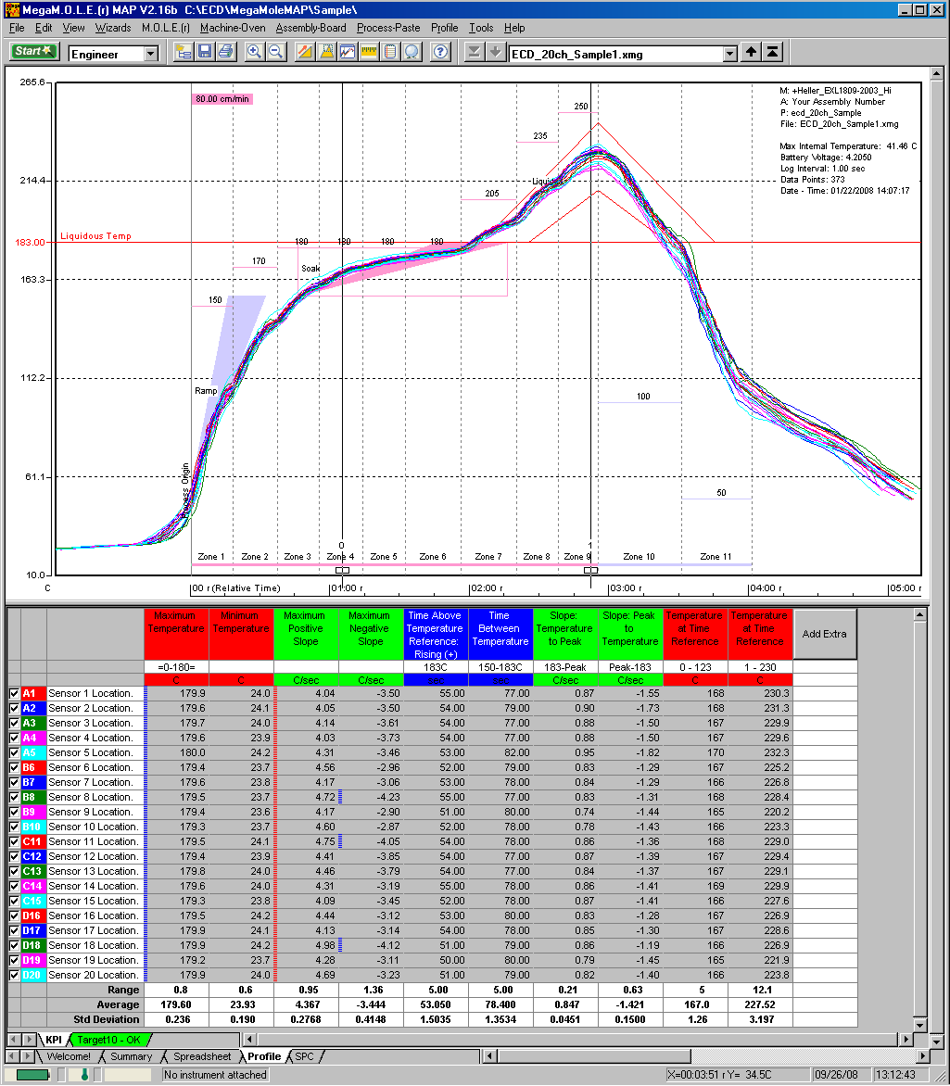

Figure 1 – Profile Using ECD’s MEGAM.O.L.E.®20 Twenty-Channel Thermal Profiler

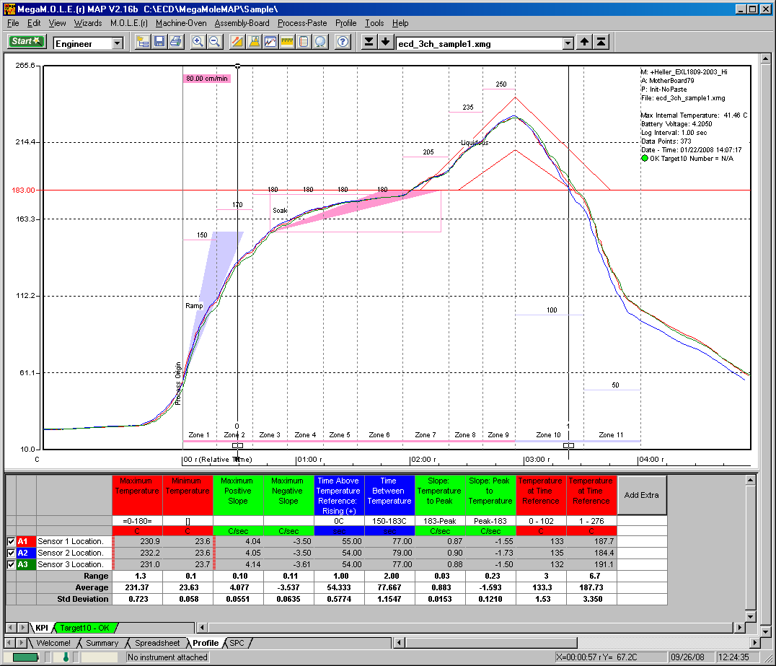

Figure 2 – Profile Using ECD’s V-M.O.L.E.® (Oven profile using a board, not a robust pallet)

What does this actually mean?
Two things stand out. The first is that once a populated board’s target profile has been established using the traditional populated board T/C placement method, and the associated oven recipe developed to reproduce that target profile, it is possible in successive runs to profile the performance of the oven, using only three T/Cs on a populated or non-populated board, and to do so on a periodic basis. Once you establish your recipe set points for each particular zone and belt speed for that oven, you will be able to maintain that target profile until and unless either the recipe changes or your oven suffers some change in its ability to transfer heat. Immediate time savings become apparent. It cannot be stressed enough, however, that in order to assure repeatability, the careful establishment of the board’s original target profile is critical.

The second thing the study showed is that this will be of particular interest to high-volume production facilities where both multiple products and multiple lines are being run. Although reprofiling must be done if products (and their recipes) differ from one to the other, it is not required if they share the same profile – as is often the case among multiple runs to complete a single job in the high-volume environment. When oven profiling is done once a week, or even daily rather than once per run, savings accrue from both saved production time – and by extension, cost – and from elimination of product wasted from either damage due to repeated profiling or from product recalls as a result of “bad runs.”

An added benefit is that this type of oven profiling is ongoing verification that all your oven zones, conveyors, and convection systems are in correct calibration across the width and length of the oven. If the oven’s ability to transfer heat causes the target profile to vary from the specification, the oven needs examination and perhaps cleaning or recalibrating. Oven temperatures may be constant, but not the actual heating or cooling levels achieved at those temperatures, if convection systems are failing due to dirt or flux buildup. Again, this is one of the perks of using an ongoing oven profiling method. Variations in the oven become apparent rather quickly, helping avert wasted runs, downtime, and loss of client product.

Conclusions
The Binghamton University study has shown that when done correctly and adhering to the original target profile, three-leading-edge-thermocouple profiling can be used to verify the original target profile that was achieved through the use of twenty thermocouples. Ideally, three-thermocouple profilers complement the traditional six-, twelve-, or twenty-channel thermal profilers that were used to characterize the PCB assembly and achieve the necessary target profile. Robust software such as ECD’s M.A.P. will allow for the appropriate documentation verifying that indeed the process was in spec with the OEM or paste manufacturer’s required profile. It is in the ability to save production time, utilize all lines, and decrease product waste, while at the same time ensuring proper documentation of process verification, that we see tremendous benefits from oven profiling in the production environment.

The entire Binghamton University study can be viewed online at www.ecd.com.

Reference:
Santos, Daryl L. and Ramasubramanian, Arun (Binghamton University); Harvilchuck, Laurence A. (Unovis Solutions). “On the Use of Three Thermocouples to Verify A Printed Circuit Board Profile During the Reflow Operation.” Binghamton, NY. September, 2008

# # #

Austen Bio:
Paul Austen is a twenty-year veteran Senior Project Engineer with ECD, in Milwaukie, OR (www.ecd.com), and holds a degree in Electrical Engineering from Portland University. Since 1964 ECD has designed, manufactured and marketed electronic and other specialized technology products worldwide, and is the developer of the newly released V-M.O.L.E.® and the only twenty-channel thermal profiler, the MEGAM.O.L.E®20. Paul can be reached for questions pertaining to this study, or thermal profiling in general at paul.austen@ecd.com

Media Contact:
Liz Richards
Richards & Lord
847-919-1119
liz@richardsandlord.com

